SEPM
Team Contract

Team Name: TBC

Version History

Version | Date | Author | Comment
0.1 | 10 March 2022 | Taylor Edgell | Initial Draft

Policy

GOALS: What are our team goals for this project? What do we want to accomplish? What skills do we want to develop or refine?
This module examines the relationships between the Project Manager and the other stakeholders in a project, and the role that the Project Manager has in ensuring that the triple constraints of project management are balanced, and any technical debt is not accrued.

For this unit we are tasked with supporting the end-to-end life cycle of developing the software that can be used in a child’s toy. We are required to collect the requirements of the customer requesting that the toy is produced, executing the development of the software that will be used in the toy, and delivering the software product to the customer.

The deliverables for this module are to create a project report, developing the toy software and providing a presentation of the project.

From this unit we endeavour to learn:
- The basic principles of Project Management and software engineering principles, recognising their relationship and interactions with other computing and design disciplines;
- An understanding of the advanced principles of architecture, Behaviour Driven Development (BDD), and traditional and contemporary Software Development Life Cycle (SDLC) models, such as TOGAF and Agile;
- The ability to integrate the approaches: conflicts and compromises;
- An efficient ability to undertake analysis, program design, software construction and testing required for software development;
EXPECTATIONS: What do we expect of one another in regard to attendance at meetings, participation, frequency of communication, the quality of work, etc.?
Team members shall;
- Fully partake in their assigned tasks and shares equally the respective workload.
- Use their skills to assist each other’s development during the module.
- Meet weekly, in an informal manner via an agreed-upon platform, to discuss each allocated task’s progress.
- Regularly engage in communication as required to provide progress updates to other team members.
- Keep other team members informed if they experience issues with a given task and whether or not they require assistance.

Although quality is subjective, each team member will complete their assigned tasks to the best of abilities. As part of teamwork, each member will help to improve quality output where necessary.
POLICIES & PROCEDURES: What rules can we agree on to help us meet our goals and expectations, such as preparatory tasks, generating ideas, evaluating outcomes?
The rules agreed upon are:

- General communication of the tasks shall take place on Discord.
- A majority vote agrees upon decisions. Consulting the tutor is required to assist with unresolved decisions.
- Discussing disagreements is impartial and open. If a conflict remains unresolved, the group shall consult with the tutor.
- Storing project artefacts must be done in a mutually accessible location, with correct version referencing.
- The group should be aware of what each person is working on. Gantt charts, spreadsheets, changelogs, or other agreed-upon artefacts help to provide progress visibility.
- A single platform will be decided upon for the weekly meetings to take place
e.g Skype, Discord, Zoom.
- The group will review each completed task to evaluate if changes are required.Time of review will be at the discretion of all team members.
- Each team member can openly present their project ideas free from fear of ridicule or other preventative measures. The idea is to foster teamwork and to listen to all opinions required for delivery.
CONSEQUENCES: How will we address non-performance regarding these goals, expectations, policies and procedures? How do we resolve disagreements?
Any issues with work quality, policy, or other disagreements will initially be discussed informally. Suppose a change is required and agreed upon by the group. In that case, the team will formally notify the member that the issue needs rectifying. Finally, suppose no change is required, and it is agreed upon by the group. In that case, the matter will be brought to the tutor for further discussion and action.

By signing this contract, we confirm that:

- we have participated in formulating these goals, expectations, roles, procedures, and consequences as stated in this contract.

- we agree to abide by the contents of this contract

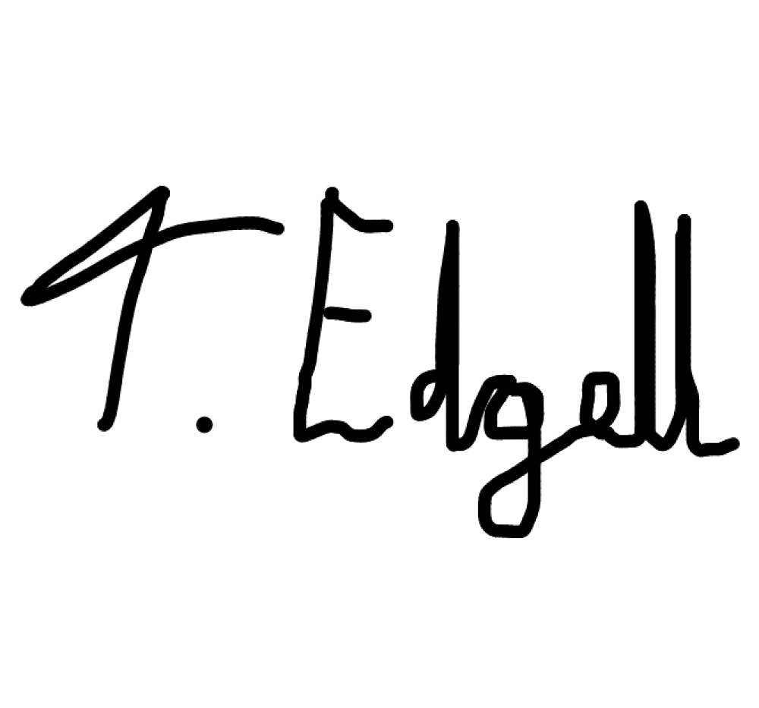
Team member name and date

Team member name and date
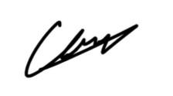

Team member name and date
Team member name and date

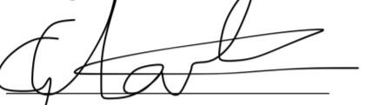

Team member name and date
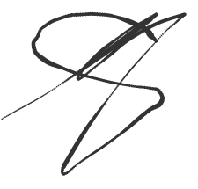

Team member name and date

