User experience can be thought of as all interactions an individual has with a company, from its digital products, to its marketing and branding (Nielsen & Norman, n.d.). Minge & Thuring (2018) extend this perspective on user experience by discussing the emotional component of an individual's interactions with products, and how that can be related to a product's quality. This notion was named the "Component Model of User Experience" (CUE model), and is primarily based on research done in the early phases of an individual using an application for a short period of time. The authors presented an original model as shown below:
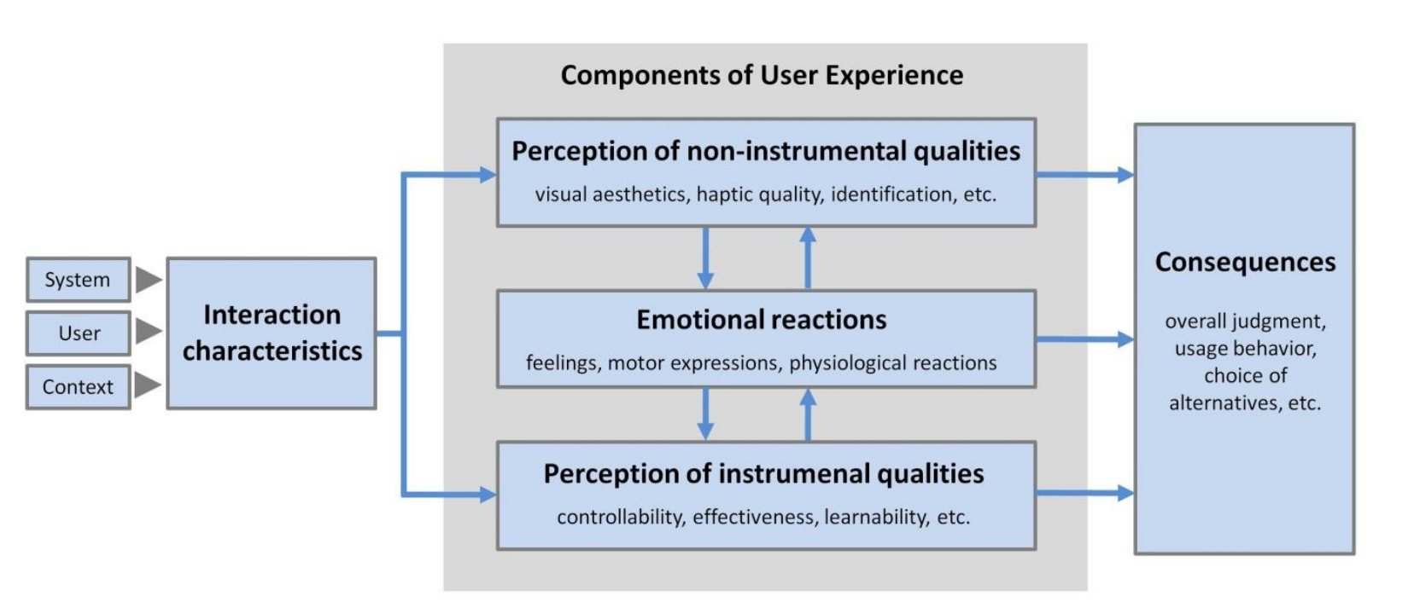
Extensions can be made to this model to better reflect user-experience in the real world. One such example is including the influence of experience in user experience: the authors discuss the perception of instrumental/non-instrumental instruments, and their associated emotional reactions. However, these aspects are subject to change due to external influences: for example, a user might discover a company with products which provide a different user experience that influences how they interpret the quality of other user experiences, or a user might come to develop specific preferences over time. As a result of the potential for change in perception due to this, it can be argued that in the CUE model, the consequences aspect of the model is not static- it is continuously influenced by other experiences, where previous experiences shape future ones, although the actual components of a single user experience would remain unchanged. I therefore suggest an updated model by using the following representation:
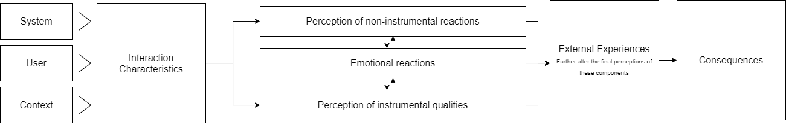
As a suggestion for further discussion, it may be worth considering the differences between time and experience (or if there are any, when it comes to this model). An argument could be made that it's not necessarily the experience itself that shapes a person's perception of a user experience, but rather, time.
References
Minge, M. & Thuring, M. (2018) Hedonic and Pragmatic Effects at Early Stages of User Experience. International Journal of Human-Computer Studies 109: 13-25.
Nielsen, J. & Morgan, D. (n.d.) Available from: https://www.nngroup.com/articles/definition-user-experience/ [Accessed 24 April 2022].

