Peer Response 1: Alice Villar
Context: https://www.my-course.co.uk/mod/hsuforum/discuss.php?d=305263
Hi Alice,
You mentioned a key limitation of the CUE model- it mainly models short-term user experience since that is how the initial experiement was structured. Academics have been researching and creating long-term models which better represent how user experience changes over longer periods of time. Karahanoğlu & Bakırlıoğlu (2022) propose a new model that represents how user experience changes long-term. This model is known as the Path of Long-Term User Experience (PLUX) model, and the authors present a simplified version (which I've attached at the bottom of this post).
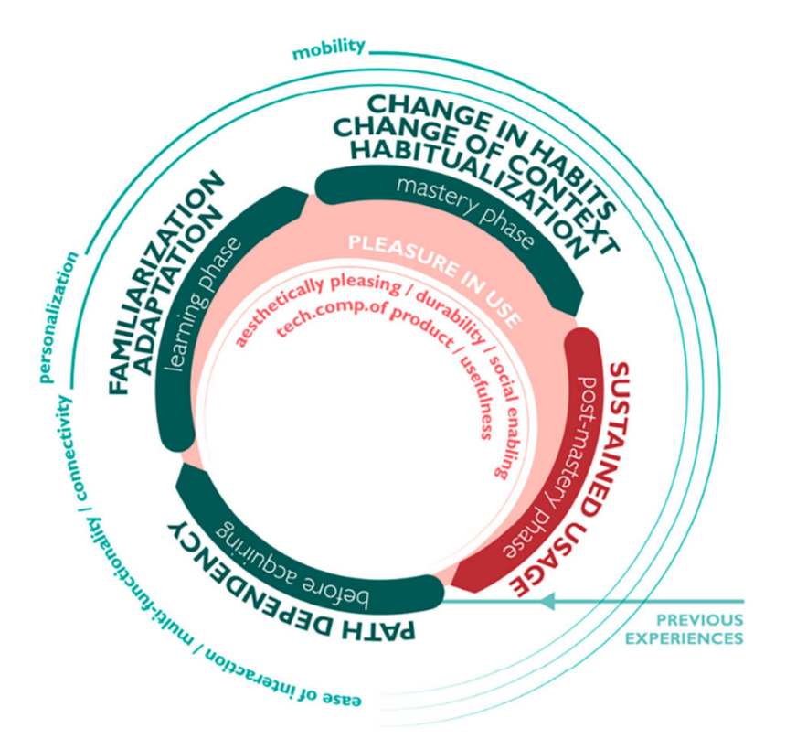
There are some clear similarities between the PLUX model and the CUE model: PLUX suggests that users experience pleasure when using the application based on its aesthetics, along with its usefulness and technological composition; in CUE, aesthetics would be a non-instrumental quality, while pleasure would be an emotional reaction, and usefulness/technological composition would be an instrumental quality. Based on this, do you think that there is value in combining CUE and PLUX? Having an integrated view of changes in user experience over the short-and-long term would make it easier to trace how users change and grow over time relative to an application, making it easier to design better user experiences. However, it would still be necessary to map the CUE concept of a consequence to the PLUX model.
References
Karahanoğlu, A. & Bakırlıoğlu, Y. (2022) Evaluation of the usefulness of path of long-term user experience model in design process. Behaviour & Information
Technology 41(4): 777-795. DOI: 10.1080/0144929X.2020.1836256

Peer Response 2: Michael Justus

Context; https://www.my-course.co.uk/mod/hsuforum/discuss.php?d=304870

Hi Michael,
I enjoyed reading your clear and intuitive ideas on improving the model. Prior experience with applications that have varied user experiences is an interesting topic, and there is a diverse discussion surrounding it in academia. A common scenario in modern times is that applications will overhaul their user experience, through updates to applications, branding, and so on. In these cases, it is critical to measure the success of these improvements, and Schrepp et al. (2014) used a questionnaire which can measures this success not only for various iterations of an application, but can also be used to compare the user experience of different competing products. The authors mention a limitation of this, which is that when comparing competitors, only high-level details can be obtained.
In light of this, and when evaluated with your expanded CUE model, would you say that perhaps the "experience" component of user experience could be better understood, if experience in this context is defined as how a user has interacted with competing products/prior version of an application, and then have this experience measured so that it becomes possible to see how components of user experience are influenced by this?
References
Schrepp, M., Hinderks, A. & Thomaschewski, J. (2014) 'Applying the User Experience Questionnaire (UEQ) in Different Evaluation Scenarios', DUXU 2014: Design, User Experience, and Usability. Theories, Methods, and Tools for Designing the User Experience. Crete, Greece, 22-27 June. Cham: Springer. 383-392.

